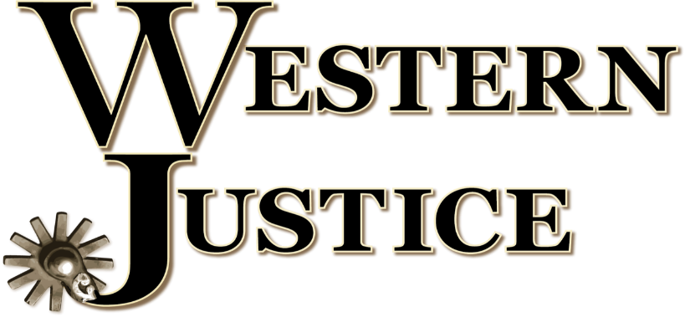

Western Justice is a nonprofit C4 organization formed to both unite the western horse industry in our common goals and to protect the rights of animal ownership, the welfare of livestock, and the future of the western horse industry for our future generations.
I formed Western Justice after conversations with multiple equine owners, breeders, and exhibitors. This group of knowledgeable horse people is rightly concerned about the increasing influence animal extremist groups are having on the horse industry and wanted to know what could be done to stop the insane legislation these groups push in all levels of government. Western Justice gives them and the entire horse industry the representation we so dearly need and frankly must have, to protect our rights and heritage with horses.
My career as an animal welfare and agriculture advocate started over 14 years ago. Most recently, I was the National Strategic Planner for Protect The Harvest. This spring, I started my own consulting business to continue advocating at a new level. My years at PTH were parallel to earning my PHD in politics. Representing Mr. Lucas and his vision for PTH was a privilege and I am forever grateful for the opportunity. Working in Washington, DC enabled me to form invaluable relationships and gave me the knowledge and the tactics needed to navigate government departments and agencies all while being recognized as the “cowboy with a voice.” I was proud to help make a difference for the individuals and groups we represented. I am looking forward to continuing that work for the horse industry.
It is a tragedy that Protect The Harvest pulled out of the horse industry earlier this year - not because the horse industry lost Protect The Harvest and Lucas Oil show sponsorships, but because Protect The Harvest walked away from the largest group supporting their mission: the horse industry. That abrupt departure showed me the value and the need for a membership-based organization vs an organization that is solely supported by a few corporate sponsors. For an organization like Western Justice to quickly become the strong voice the horse industry needs, the financial support should come from the individual people we are representing.
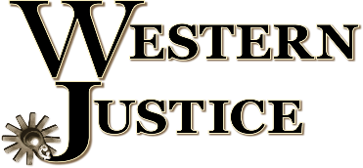
With my consulting business off and running, I knew I would need an experienced and dedicated team to ensure Western Justice’s success. Luckily, I already had one readymade. A couple things I’ve learned about advocacy are that you can’t unlearn what you know and it’s very hard to stop fighting when you know what is at stake. So, I called several former PTH team members, and all of them were on board to establish Western Justice.
Our team offers a robust level of expertise in policy, public relations, marketing, advertising, research and writing, and most importantly, we are all vested in the horse industry. We are multigenerational ranchers, vet techs, competitors, trainers and/or breeders.
We hit the ground running, diligently working to launch Western Justice. We now have a presence on all social media platforms as well as a growing website. We are researching the current issues and strategizing my next visit to Washington D.C. Membership numbers are on the rise as we work to educate the horse industry about who we are and what we offer. The faster we grow, the quicker our voice has power, uniting our industry to protect our western way of life. In reality, the western horse community is the largest segment of US horses and we encourage anyone that is involved with or just loves horses to become a member of Western Justice.
Sincerely,
Dave Duquette

