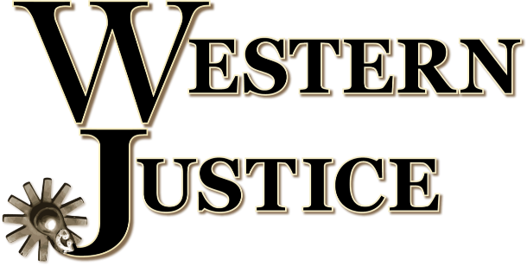
As our nation enters an era of a new administration, the role of Western Justice is of heightened importance in the mission to defend, preserve, and enhance our beloved Western lifestyles and livelihoods. The Western Justice team works diligently to inform the public about the issues facing our industry, and engages directly with policy-makers at all levels of government about those same issues.
In the coming months, Western Justice will focus substantial energy into communications with the key incoming cabinet members who are poised to greatly affect numerous aspects of the Western horse industry. Of particular interest to us are Secretary of Agriculture, Tom Vilsack; Secretary of Transportation, Pete Buttigieg; Secretary of the Interior, Deb Haaland; and EPA administrator, Michael Regan.
These individuals will play central roles in determining numerous policies that directly and profoundly affect our industry, from the way we raise livestock to the price we pay for fuel to drive to horse shows.
Tom Vilsack is presently the CEO of the U.S. Dairy Export Council, and most notably, previously held the position of Secretary of Agriculture during the 8-year Obama administration. He was also the governor of Iowa from 1999 to 2007. As leader of the USDA, Vilsack will again lead 29 agencies with approximately 100,000 employees among them. Together, the branches of the USDA oversee a range of agriculture-related items, such as food and nutrition, natural resources, conservation, and rural development. Also under the purview of the USDA is the United States Forest Service, which manages the grazing rights of hundreds of ranchers.
In his role as Secretary of Agriculture, Vilsack will have a great deal of influence on the nation’s farms, ranches, and horse operations.
Pete Buttigieg is a former presidential candidate, having withdrawn from the 2020 race in March. He was the mayor of South Bend, Indiana from 2012 to 2020 and also served as an intelligence officer in the US Navy Reserve. The Department of Transportation is comprised of 50,000-some employees, and oversees the airline industry, railroads, commercial trucking, mass transit, and pipelines.
Within Buttigieg’s pending jurisdiction, the ELD mandate is of special concern to Western Justice.
Deb Haaland has been the U.S. Representative for New Mexico’s 1st congressional district, which includes Albuquerque, since 2019. She is a former chairwoman of the Democratic Party of New Mexico and a member of the Laguna Pueblo. Her website describes her as “a fierce advocate for racial, economic, & environmental justice.”
The Department of the Interior is primarily responsible for the management of federal land and natural resources, working through agencies such as the United States Geological Survey, Bureau of Indian Affairs, National Park Service, the US Fish and Wildlife and the Bureau of Land Management—another agency tasked with the management of ranchers’ grazing rights.
Michael Regan is currently the head of North Carolina’s Department of Environmental Quality. In the past, he worked as an EPA air quality official under the administrations of both Bill Clinton and George W. Bush, and spent time as part of the team of the Environmental Defense Fund.
Among other things, the EPA regulates pollution from vehicles, factories, oil and gas wells, power plants, and monitors the nation’s emissions of greenhouse gases and is in charge of the Waters of the US.
Following his nomination to lead the EPA, Regan was quoted as saying “Climate change is the most significant challenge humanity faces.”
Western Justice looks forward to the opportunity to represent our industry in working with the incoming administration. In this pivotal time, your support is more crucial than ever. Please join us and help strengthen our voice. We will be highlighting different issues in the coming weeks that may not seem on the surface to affect us as an industry, but indeed will by proxy.

