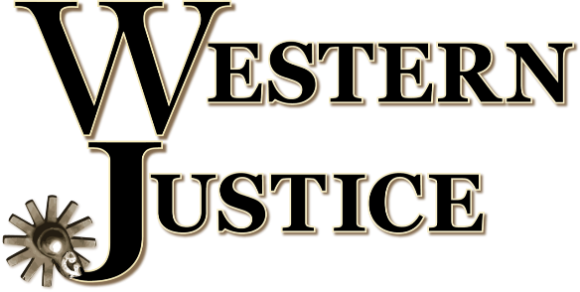

The first month of the Biden presidency has powerfully demonstrated the danger of the “progressive” agenda, and the level of vindictiveness the new administration has toward anything and anyone that benefitted from the leadership of Donald J. Trump. More executive orders were signed by Biden in that short time than by any other president in history.
Tragically, the petty vengeance is coming from multiple directions within the federal government—not just the executive branch. A senior adviser at the Department of the Interior (DOI) has rescinded the long-embattled grazing permit of Oregon’s Hammond family. The Bureau of Land Management (BLM) falls under the umbrella of the DOI, and manages hundreds of grazing allotments in the American West. As part of a multiple use mandate, Western ranchers own grazing rights on millions of acres of federally managed land.
The Hammonds’ grazing permit had been restored by the former Secretary of the Interior David Bernhardt in late 2020, which should have been the end of a long saga. Four environmental extremist groups filed suit regarding restoration of the permit, and it was a mere day later that DOI employee, Laura Daniel-Davis signed the memo to rescind.
While with Protect The Harvest, our team did extensive work to help the Hammonds. Read more here: https://protecttheharvest.com/search/?q=hammond
Following former Secretary Bernhardt’s decision to restore the Hammond permit, there was a slight procedural error that is the basis of the filed lawsuit, and which is now being used as the excuse to rescind, with no thought or consideration given to the devastating effects on the Hammond family, the ranching community as a whole, and the hard-won and often fragile trust between ranchers and land management agencies—not to mention the negative environmental impact.
The Oregon Farm Bureau issued the following statement:
“The Hammond family are long-standing pillars of the Harney County community who have been subjected to continued government overreach while sustainably managing their ranch for the benefit of the local community, local ecosystems, and generations of their family. The decision to issue their grazing permit should be a criteria-based process, and one that BLM approaches objectively. The Hammonds have demonstrated several times that all applicable factors favor them being restored their permit, including the family’s record of stewardship, their ownership of intermingled private land and several range improvements, and their contributions to the local economy. It is fundamentally unfair to continually subject this family to ever-changing regulatory whims, and in the process, jeopardize their livelihood, proper rangeland management, and ability to fully utilize their private lands. The Hammond’s permit should be restored, and the family should be allowed to move forward with their lives in peace.’'
Properly managed grazing is essential for the health of rangeland ecosystems for many reasons, perhaps the most significant being that it greatly reduces fuel load and resulting fire risk. In forests and on rangeland both, managing the amount of material available to burn is the sole contributing factor of fires that can easily, sustainably be controlled by humans—but instead, recent years have seen hundreds of thousands of acres of the West being decimated by fire, because proactive management has been stifled by the lawsuits of environmental extremist groups. As a result, immeasurable natural resources, wildlife—including countless endangered animals, entire communities, and human lives have been incinerated in the name of “conservation.”
Biden’s pick for Secretary of the Interior, Deb Haaland, is currently awaiting confirmation. Haaland is a supporter of the New Green Deal and is staunchly against energy development on federally managed lands. She was quoted in a 2019 Los Alamos Monitor story as saying, “climate change in the U.S. started when Europeans arrived and started killing the buffalo.”
Ironically, Haaland sells herself as a champion for “environmental justice,” the meaning of which has seemed somewhat unclear until now.

https://news.yahoo.com/deb-haaland-could-disaster-interior-172252613.html

